Gold Price Prediction ML Project
MILESTONE 6: FINAL CLASSIC REPORT
• Team Name: Team Gold
• Team Members: Naina Kalra
Introduction
The goal of this project was to predict the direction of gold prices, whether the price would go up or down the next day. Gold is one of the most traded commodities in the world and its price is affected by many factors like inflation, global uncertainty, and currency values. Predicting its direction is a hard problem because financial markets are noisy and unpredictable, but even a small edge above 50% accuracy can be meaningful.
This project was divided into 5 milestones. Each milestone was built on the previous one, starting from when the class began with loading and exploring the data, all the way to training and evaluating a final machine learning model.
Dataset
The dataset used is historical daily gold price data with the following details:
- Total Rows - 2,510 daily records
- Columns - Date, Open, High, Low, Close, Adj Close, Volume
- Time Period - Approximately 2016 to 2024
- Missing Values - None
- Target Variable - 1 = Price went UP,
0 = Price went DOWN

Milestone 1 – EDA(exploratory data analysis)
The first step was to load the dataset and understand it. I checked the shape of the data, column types, summary statistics, and whether there were any missing values.
I converted the Date column to proper datetime format and extracted Year, Month, Day, and Weekday as separate features.
Visualizations I created –
- Gold Price Over Time (Line Chart): Showed that gold had a clear upward trend, especially from 2019 onwards.
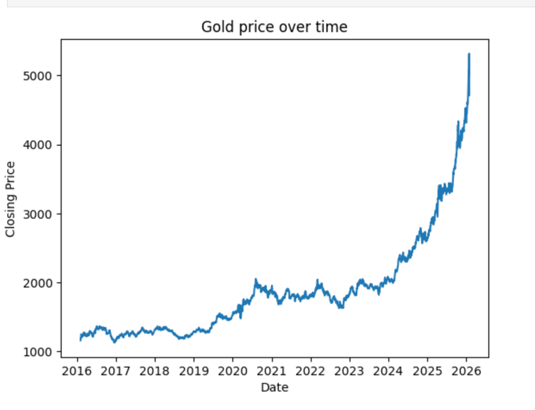
- Price Distribution (Histogram): Showed the spread of closing prices across the dataset.
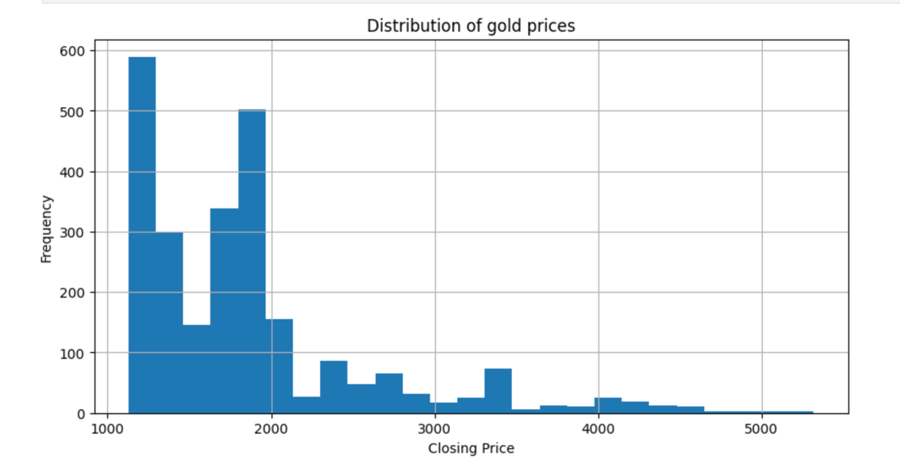
- Correlation Heatmap: Showed that Open, High, Low, and Close are very strongly correlated with each other.
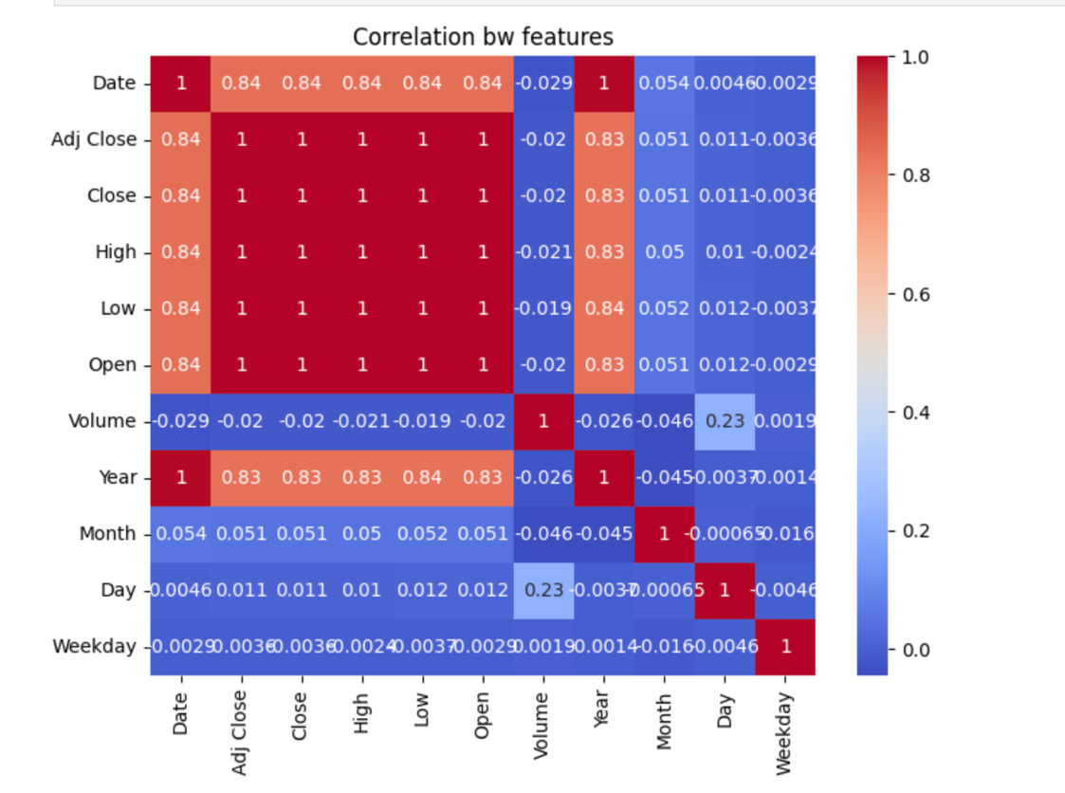
- Closing Price by Year (Boxplot): Helped see how price ranges changed year by year.
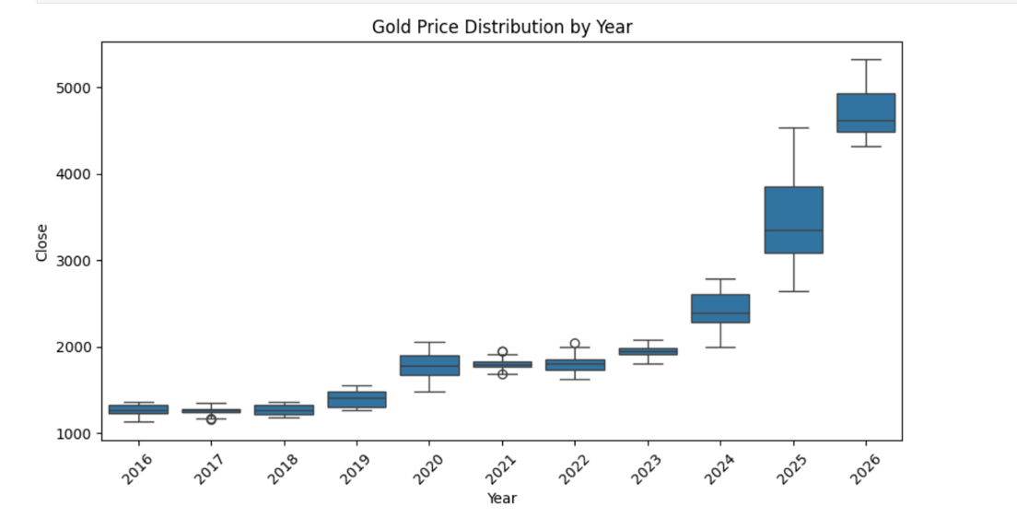
- Volume vs Closing Price (Scatter Plot): Showed no strong relationship between trading volume and price.
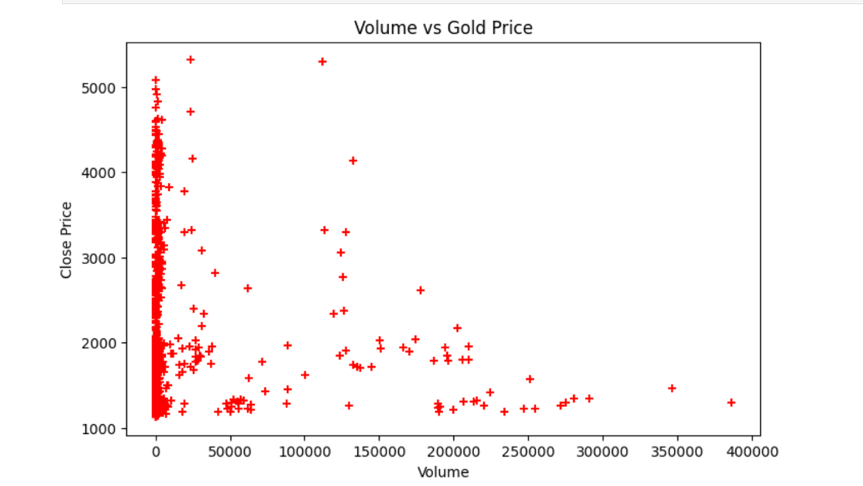
Milestone 2 – Data Preparation
In this milestone I prepared the data for machine learning. Since there were no missing values or categorical columns, the main tasks were feature selection, scaling, and splitting.
-> Steps done:
- Features selected - Open, High, Low, Volume, Year, Month, Day, Weekday
- Target variable - Close (actual closing price, for the baseline regression model)
- Scaling -MinMaxScaler applied to bring all features to a 0-1 range
- Split - 70% training, 24% validation, 6% test using random split
***The random split used here later became a problem for time series data. I fixed that in Milestone 4.
Milestone 3 – Baseline Model
To establish a benchmark, I trained a simple Linear Regression model to predict the actual gold closing price. This was a regression task, predicting a number and not a direction.

Its results are:
- MSE: 58.94
- RMSE: 7.68
- MAE: 4.45
RMSE of 7.68 means predictions were on average about $7.68 away from the actual price. For gold trading in the $1,000 to $2,500 range, this is quite good for a simple base model. I also plotted Actual vs Predicted prices to visually confirm the model was learning the trend.
Milestone 4 – Developing model
In this milestone I completely changed the approach. Instead of predicting the actual price (regression), I switched to predicting whether the price would go UP or DOWN the next day (classification). This gives a more actionable signal.
- Feature Engineering - I rebuilt the features from scratch to avoid data leakage. The key idea was to only use yesterday's data to predict today's direction.

- Prev_Close -Yesterday's closing price (it was shifted by 1 day)
- Return_1d - 1-day percentage change
- Return_5d - 5-day percentage change (momentum signal)
- Vol_5d - 5day standard deviation (short-term volatility)
- Vol_Ratio - Ratio of 5-day to 20-day volatility
- Z_Score_20 - how far current price is from its 20-day moving average
- RSI or Relative Strength Index, it measures if gold is overbought or oversold

- Data Split and Scaling -
- Chronological Split - First 80% of dates = training, last 20% = test.
- Random split is never used for time series because it leaks future data into training.
- RobustScaler – It was used instead of MinMaxScaler because gold data has outliers like sudden price spikes.

- Handling Class Imbalance
The dataset had more UP days than DOWN days. I used scale_pos_weight in XGBoost to give more importance to the minority class so the model does not just always predict UP.
- Hyperparameter Tuning
I used RandomizedSearchCV with TimeSeriesSplit (5 folds) to find the best hyperparameters. It tested 30 random combinations of settings like number of trees, tree depth, learning rate, and subsampling. Scoring was based on F1 score as accuracy alone can be a bit misleading with imbalanced classes.
Results -
 | Precision | Recall | F1 Score
Price Down | 0.46 | 0.37 | 0.41
Price UP | 0.62 | 0.71 | 0.66

Overall Accuracy: 0.57 (498 test samples)
57% accuracy means that the model is right more often than random guessing (50%). The model is better at catching UP days (71% recall) than DOWN days (37% recall), probably because gold trended upward during the training period.

Milestone 5 - finalizing model
In this milestone I compared XGBoost with Random Forest to confirm my final model choice and documented the strengths and limitations.
Model Comparison
 | Accuracy | Down Recall | UP Recall | Balance
XGBoost | 0.57 | 0.37 | 0.71 | Yes
Random Forest | 0.53 | 0.08 | 0.95 | No

XGBoost was chosen as the final model because it had higher accuracy and was more balanced. Random Forest had very high UP recall (0.95) but almost completely ignored DOWN days (0.08 recall), so it was kind of unreliable.
Strengths
1. No data leakage – as I used Prev_Close and chronological split throughout.
2. Class imbalance was handled using scale_pos_weight in XGBoost.
3. Proper time-series cross-validation was done using TimeSeriesSplit.
4. 57% accuracy is meaningful as random guessing gives 50% for binary classification.
5. Feature importance available - Vol_Ratio and Return_5d were the top predictors.
Limitations
1. Model has a bullish bias – as it is better at predicting UP (71% recall) than DOWN (37% recall).
2. Precision for DOWN is 0.46, like when it predicts DOWN, it is wrong more than half the time.
3. It only uses price-based technical indicators and has no external data like inflation or USD index.
4. Threshold is 0.35 instead of the standard 0.5, showing the model is not very confident.
5. The dataset is relatively small as it has 2,510 rows of daily data for about 10 years.

Conclusion
This project taught me a lot about applying machine learning to real financial data. The biggest challenge was avoiding data leakage, like it is easy to accidentally let the model see future data, which makes results look much better than they actually are. By using chronological splits, lag features, and TimeSeriesSplit cross-validation, I made sure the model was being evaluated fairly.
The final XGBoost model achieved 57% accuracy on unseen test data. While this might seem low, predicting daily gold price direction is a genuinely hard problem. The model shows real predictive signal and handles both classes reasonably well.
If I had more time, I would try adding external features like the USD index, inflation data, or global news sentiment, which could improve the model's ability to predict DOWN days in particular, which I will do in the future.

• GITHUB URL - https://github.com/NainaKalra/gold-price-prediction

